Diode Circuits HW 1 (33 points)
(jas, Diode Circuits HW 1.docx, 5/08/2025)

Clearly indicate answers and include units for numeric answers, using 3 or 4 significant figures. Show at least the major steps of your work so that if necessary partial credit can be awarded.

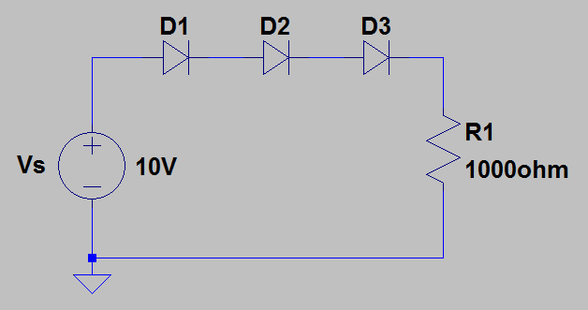
- Using the Simplified Diode Model, i.e., 2nd approximation, with V_{K} = 0.7 V for a forward biased diode, calculate the current through resistor R1 in the adjacent schematic, including units. (2 Points.)

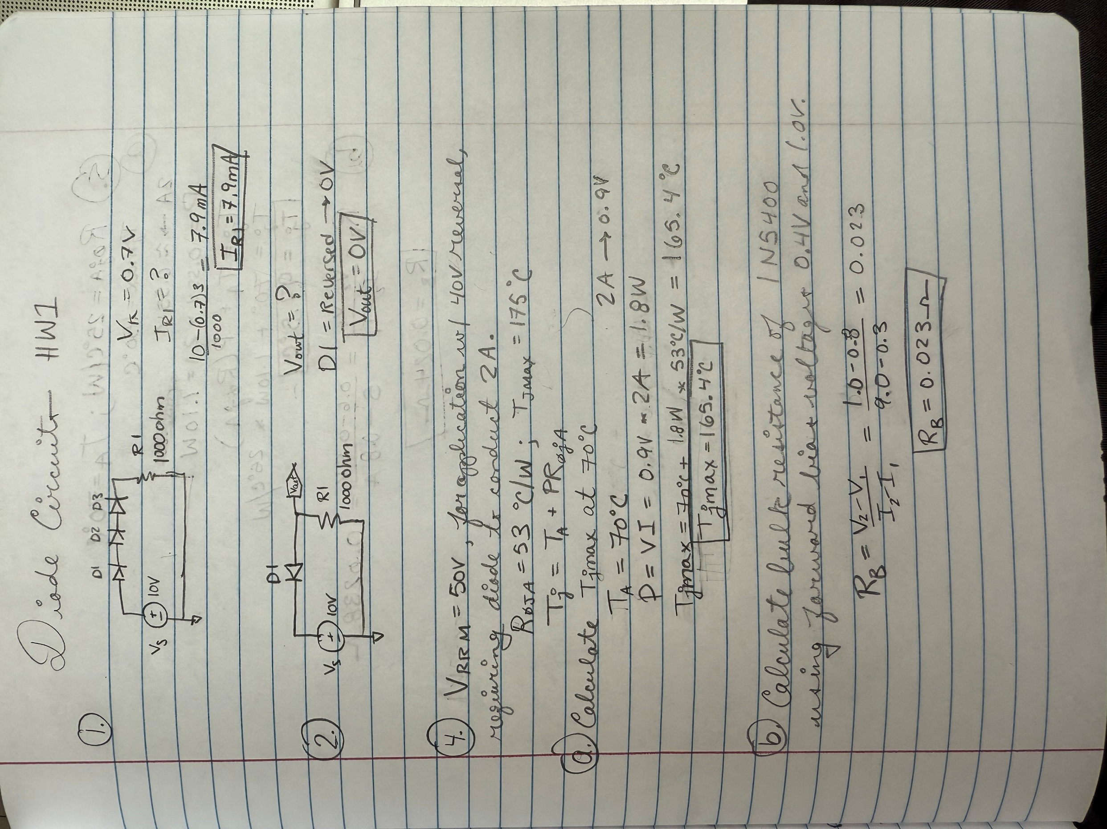

Using LTspice connect up the circuit of the previous problem, using the diode symbol to place silicon pn junction diodes. After placement of the diodes, they are to be changed from the generic LTspice silicon pn junction diode to 1N4007 diodes. This can be accomplished by hovering the hand symbol over the diode and then right clicking to open a diode parameter pane, which includes a Pick New Diode button. The Pick New Diode button opens a Select Diode pane with many available diode simulation models, including the 1N4007. Sorting the list by clicking on Part No. will position the 1N4007 diode model either near the top or bottom of the list. Click on the 1N4007 Part No. and then click OK to configure the diode symbol on the schematic to use the 1N4007 diode simulation model. The three diodes placed on your schematic are to all be configured as 1N4007 diodes for simulation. The diode type can also be changed simply by editing the value from D to 1N4007 on the schematic, although becoming familiar with the LTspice parts libraries is helpful.

There is now an older and newer version of LTspice, with some nomenclature differences between the two versions. The older version included a .op for Operating Point icon in the top toolbar, whereas the newer version uses .t for the same function, which opens a Spice Directive window. A Spice Directive window can also be opened by choosing Spice Directive in the Edit pull-down menu in the upper left-hand corner of the LTspice window. A Spice Directive window is where simulation commands and model parameters are entered for inclusion on an LTspice schematic.

Next on the Edit pull-down menu in the upper left-hand corner of the LTspice window, choose the text option to add your name to your schematic. Then on the Edit pull-down menu in the upper left-hand corner of the LTspice window, choose Spice Directive, which opens an edit pane in which to enter the .op Spice command for an Operating Point Analysis, which after running the simulation returns a numeric Operating Point pane including the voltage at every circuit node along with the conventional current flowing through each circuit element. LTspice displays voltages and current in units of Volts and Amps, respectively. The simulated current of the series circuit should be near 8 mA for the 1N4007 diode model. (Note: Negative I(R1) values occur if resistor R1 is rotated so that current flows out, instead of into what LTspice considers pin 1). Move the Operating Point Results Pane to the right of your schematic and then resize the screen if needed followed by taking a screen capture both your schematic and Operating Point Results Pane. Replace the resulting screen capture below with your version. (7 Points.)

NOTE: My version of LTSpice doesn’t have a model for the 1N4007 diode. So I made my own.
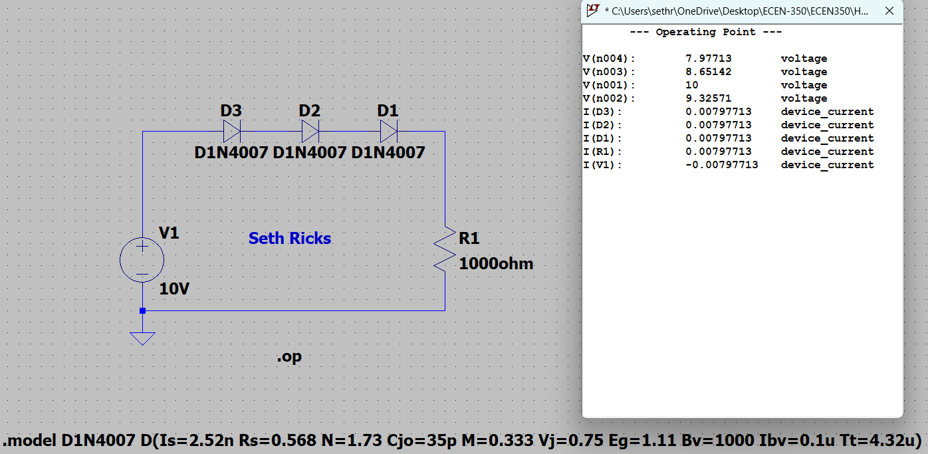
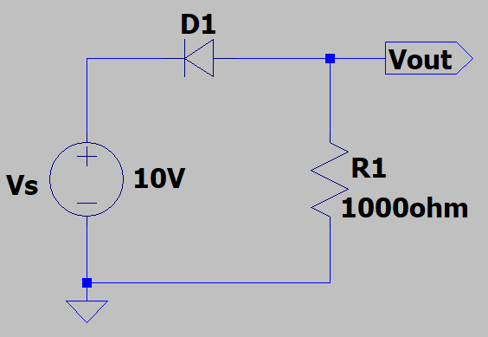
- Using the Simplified Diode Model, i.e., 2nd Approximation, with V_{K} = 0.7 V for a forward biased diode, calculate the voltage V_{out} in the adjacent schematic, including units. (2 Points.)

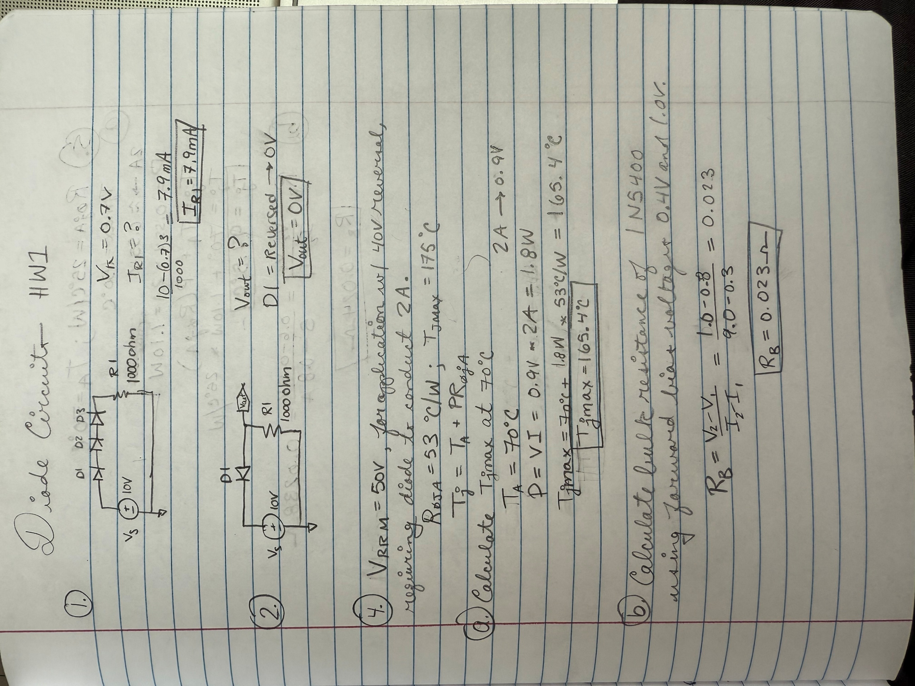

- Using LTspice connect up the circuit of the previous problem, including the Vout Net Label by means of the Net Label icon on the top toolbar, along with your name on your schematic by choosing the text option available in the Edit pull-down menu. Using Edit SPICE Directive, add the .op command to perform operating point analysis on your circuit. The simulated current of the series circuit should have a magnitude < 0.2 nA for the 1N4007 diode model. (Note: Negative I(R1) values occur if resistor R1 is rotated so that current flows out, instead of into what LTspice considers pin 1). Move the Operating Point Results Pane to the right of your schematic and then resize the screen if needed followed by taking a screen capture both your schematic and Operating Point Results Pane. Replace the resulting screen capture below with your version. (6 Points.)

NOTE: My version of LTSpice doesn’t have a model for the 1N4007 diode. So I made my own.
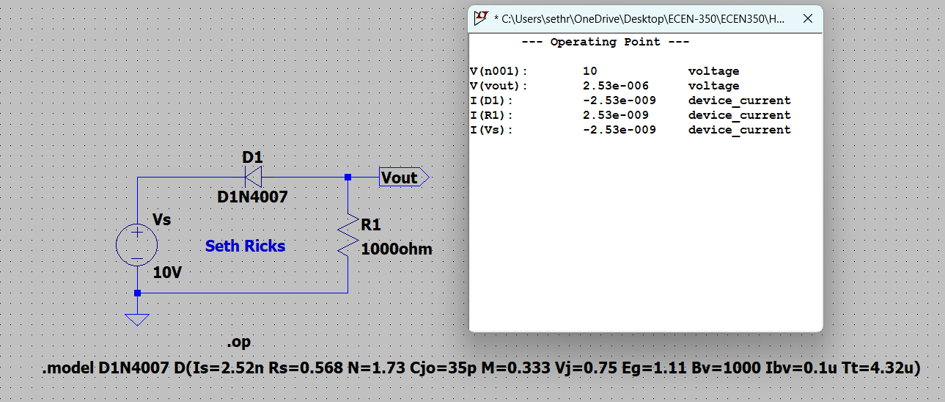

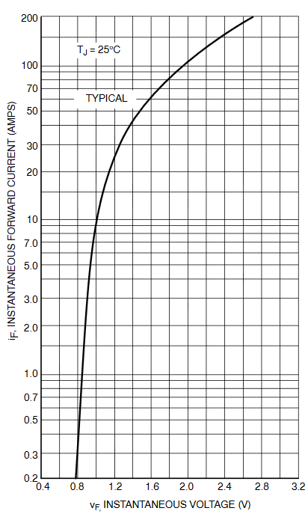
- A 1N5400 silicon pn junction diode with V_{RRM} = 50 V is to be considered for a 40 V reversal protection application requiring the diode to conduct up to 2 A continuous current. The 1N5400 data sheet includes the adjacent I-V curve in forward bias, along with a specified R_{θJA} = 53 ˚C/W, and T_{Jmax}= 175 ˚C. (8 points total.)

- Calculate the worst-case operational junction temperature, i.e., T_{J_max} at given a maximum ambient temperature of 70 ˚C including your calculations along with units, given the equation T_{J} = T_{A} + P(R_{θJA}) as discussed in class. (5 points.)

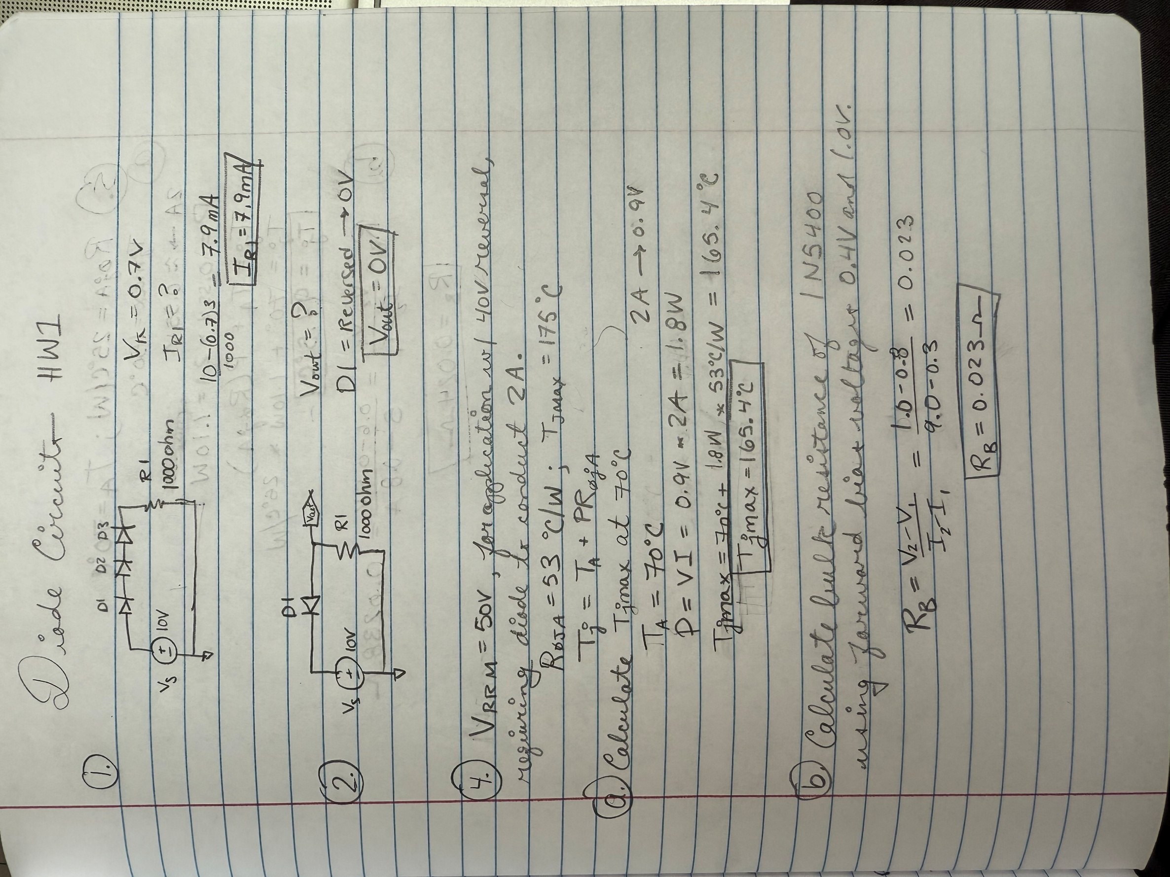

T_{J_max} = $165.4 °C$

- Based on the above I-V curve, calculate the bulk resistance of the 1N5400 using forward bias voltages of 0.8 V and 1.0 V, including your calculations along with units. (3 points.)



R_{B} = $0.023 Ω$

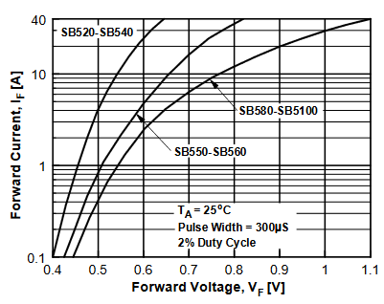
- Schottky, i.e., metal-semiconductor, diodes have a lower barrier potential than standard silicon pn junction diodes. Consider the SB550 Schottky diode with V_{RRM} = 50 V for the same 40 V reversal protection application requiring the diode to conduct up to 2 A continuous current. The SB550 data sheet includes the adjacent I-V curve in forward bias, along with a specified R_{θJA} = 25 ˚C/W, and T_{Jmax}= 150 ˚C. (8 points total.)

- Calculate the worst-case operational junction temperature, i.e., T_{J_max} at given a maximum ambient temperature of 70 ˚C including your calculations along with units, given the equation T_{J} = T_{A} + P(R_{θJA}) as discussed in class. (5 points.)

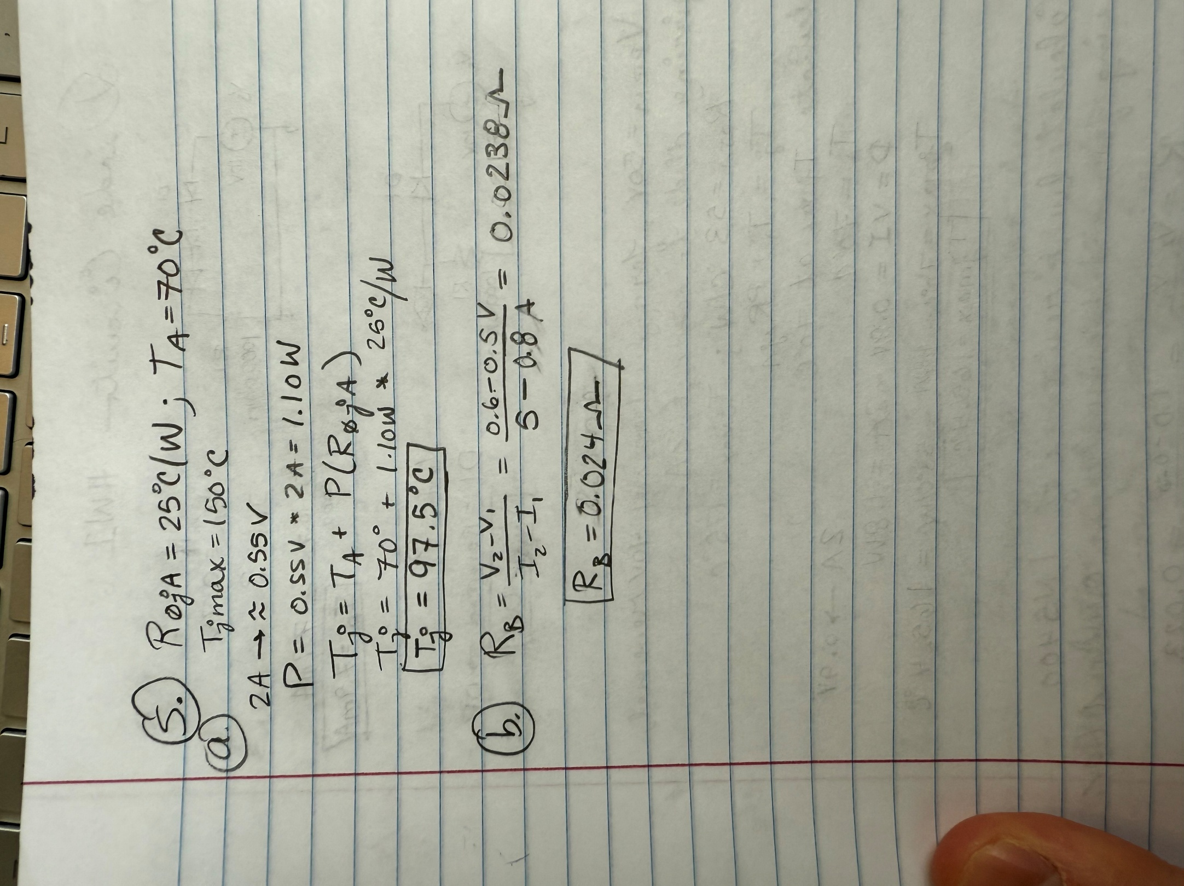

T_{J_max} = $97.5 °C$

- Based on the above I-V curve, calculate the bulk resistance of the SB550 using forward bias voltages of 0.5 V and 0.6 V, including your calculations along with units. (3 points.)

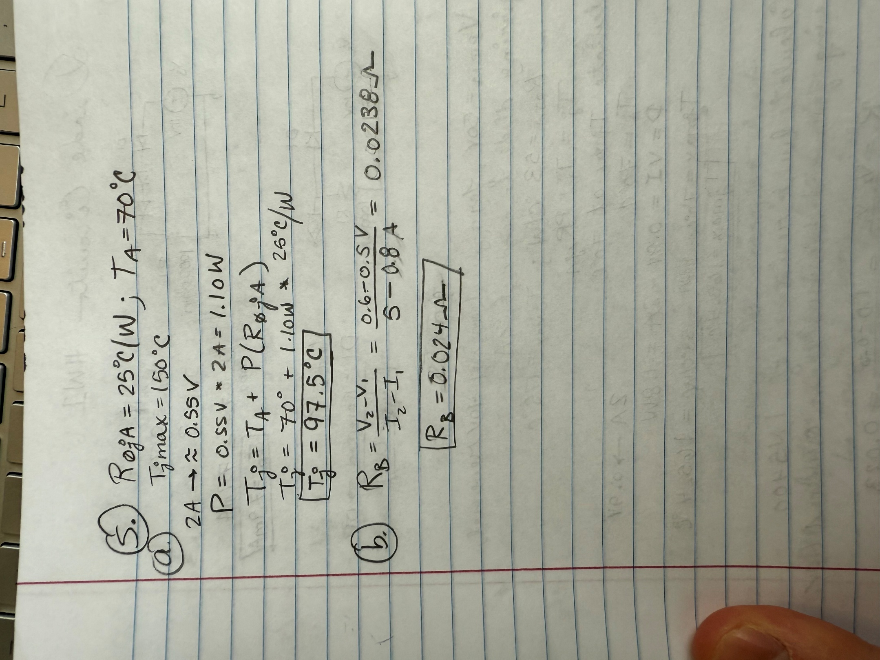

R_{B} = 0.024 Ω

